**STREAMS ASSIGNMENT**

**Q1**

Setup:

Create the following classes:

class Fruit { String name; int calories; int price; String color; }

**Display the following:**

**1. Display the fruit names of low calories fruits i.e. calories < 100 sorted in descending order of calories.**

**2. Display color wise list of fruit names.**

**3. Display only RED color fruits sorted as per their price in ascending order.**

**Code Specifications:**

**c**lass Fruit {  
    private String name;  
    private int calories;  
    private int price;  
    private String color;  
}  
  
public class Assignment5Q1 {

    public static List<String> reverseSort(ArrayList<Fruit> fruits) {}  
    public static ArrayList<Fruits> sort(ArrayList<Fruits> Fruits) {}

    public static ArrayList<Fruit> filterRedSortPrice(ArrayList<Fruit>

    public static void main(String[] args) {}

}

package com.company

import java.util.*;  
import java.util.stream.Collectors;  
import java.util.stream.Stream;  
  
class Fruits {  
 String name;  
 int calories;  
 int price;  
 String color;  
  
 public String getName() {  
 return name;  
 }  
  
 public void setName(String name) {  
 this.name = name;  
 }  
  
 public int getCalories() {  
 return calories;  
 }  
  
 public void setCalories(int calories) {  
 this.calories= calories;  
 }  
  
 public int getPrice() {  
 return price;  
 }  
  
 public void setPrice(int price) {  
 this.price= price;  
 }  
  
 public String getColor() {  
 return color;  
 }  
  
 public void setColor(String color) {  
 this.color= color;  
 }  
  
 @Override  
 public boolean equals(Object o) {  
 if (this == o) return true;  
 if (!(o instanceof Fruits)) return false;  
 Fruits fruits= (Fruits) o;  
 return calories == fruits.calories&&price == fruits.price&&color.equals(fruits.color);  
 }  
  
 @Override  
 public int hashCode() {  
 return Objects.*hash*(calories, price, color);  
 }  
  
 public static Comparator<Fruits>*color1* = new Comparator<Fruits>() {  
 @Override  
 public int compare(Fruits o1, Fruits o2) {  
 return o1.getColor().compareTo(o2.getColor());  
 }  
 };  
  
 public static Comparator<Fruits>*calories1* = new Comparator<Fruits>() {  
 public int compare(Fruits f1,Fruits f2){  
 return f2.getCalories()-f1.getCalories();  
 }  
 };  
  
 public static Comparator<Fruits>*price1* = new Comparator<Fruits>() {  
 @Override  
 public int compare(Fruits o1, Fruits o2) {  
 return o1.getPrice()-o2.getPrice();  
 }  
 };  
}  
  
  
public class Assignment_07_Q1 {  
  
  
 public static List<String>reverseSort(ArrayList<Fruits>fruits) {  
 List<String>list = new ArrayList<>();  
 ArrayList<Fruits>fruits2 = new ArrayList<>();  
  
 fruits2 = (ArrayList<Fruits>) fruits.stream().filter((fruits1 -> {return fruits1.getCalories()<100;})).collect(Collectors.*toList*());  
  
 Collections.*sort*(fruits2,Fruits.*calories1*);  
  
 for(Fruits f: fruits2){  
 String string= f.getName();  
 list.add(string);  
 }  
  
 return list;  
 }  
 public static ArrayList<Fruits>sort(ArrayList<Fruits>fruits) {  
 Collections.*sort*(fruits,Fruits.*color1*);  
 return fruits;  
 }  
  
 public static ArrayList<Fruits>filterRedSortPrice(ArrayList<Fruits>fruits){  
 fruits = (ArrayList<Fruits>) fruits.stream().filter((fruits1 -> {return fruits1.getColor().toUpperCase().equals("RED");})).collect(Collectors.*toList*());  
 Collections.*sort*(fruits,Fruits.*price1*);  
 return fruits;  
 }  
  
 public static void main(String[] args) {  
  
 ArrayList<Fruits>arrayList= new ArrayList<>();  
 int choice;  
 Scanner sc= new Scanner(System.*in*);  
 do {  
 System.*out*.println("\n1. ENTER THE FRUITS");  
 System.*out*.println("2. DISPLAY THE FRUITS");  
 System.*out*.println("3. DISPLAY THE FRUIT NAMES OF LOW CALORIES FRUITS");  
 System.*out*.println("4. DISPLAY COLOR WISE LIST OF FRUIT NAMES");  
 System.*out*.println("5. DISPLAY ONLY RED COLOR FRUITS SORTED AS PER THEIR PRICE IN ASCENDING ORDER");  
 System.*out*.println("6. EXIT");  
 System.*out*.println("ENTER YOUR CHOICE: ");  
 choice = sc.nextInt();  
 switch (choice){  
  
 case 1:  
 Fruits fruits= new Fruits();  
 System.*out*.print("Enter the name of fruit: ");  
 String name = sc.next();  
 fruits.setName(name);  
 System.*out*.print("Enter the calories in fruit: ");  
 int calories = sc.nextInt();  
 fruits.setCalories(calories);  
 System.*out*.print("Enter the price of the fruit: ");  
 int price = sc.nextInt();  
 fruits.setPrice(price);  
 System.*out*.print("Enter the color of the fruit: ");  
 String color= sc.next();  
 fruits.setColor(color);  
  
 arrayList.add(fruits);  
 break;  
  
 case 2:  
 System.*out*.println("Fruits in the List are: ");  
 for(Fruits i: arrayList){  
 System.*out*.println("Name: "+i.getName()+", Calories: "+i.getCalories()+", Price: "+i.getPrice()+", Color: "+i.getColor());  
 }  
 break;  
  
 case 3: List<String>list = new ArrayList<>();  
  
 list = *reverseSort*(arrayList);  
  
 for (String str: list){  
 System.*out*.println("Fruit Name: "+str);  
 }  
 break;  
  
 case 4: ArrayList<Fruits>arrayList1 = new ArrayList<>();  
  
 arrayList1 = *sort*(arrayList);  
  
 for(Fruits fruits1: arrayList1){  
 System.*out*.println("Fruit Name: "+fruits1.getName()+", Fruit Color: "+fruits1.getColor());  
 }  
 break;  
  
 case 5: ArrayList<Fruits>arrayList2 = new ArrayList<>();  
 arrayList2 = *filterRedSortPrice*(arrayList);  
  
 for (Fruits fruits1: arrayList2){  
 System.*out*.println("Fruit Name: "+fruits1.getName()+", Fruit Price: "+fruits1.getPrice());  
 }  
 break;  
 case 6: System.*exit*(0);  
  
 default:  
 System.*out*.println("PLEASE ENTER THE RIGHT CHOICE!!");  
  
 }  
 }while (choice!=6);  
 }  
}

OUTPUT :-

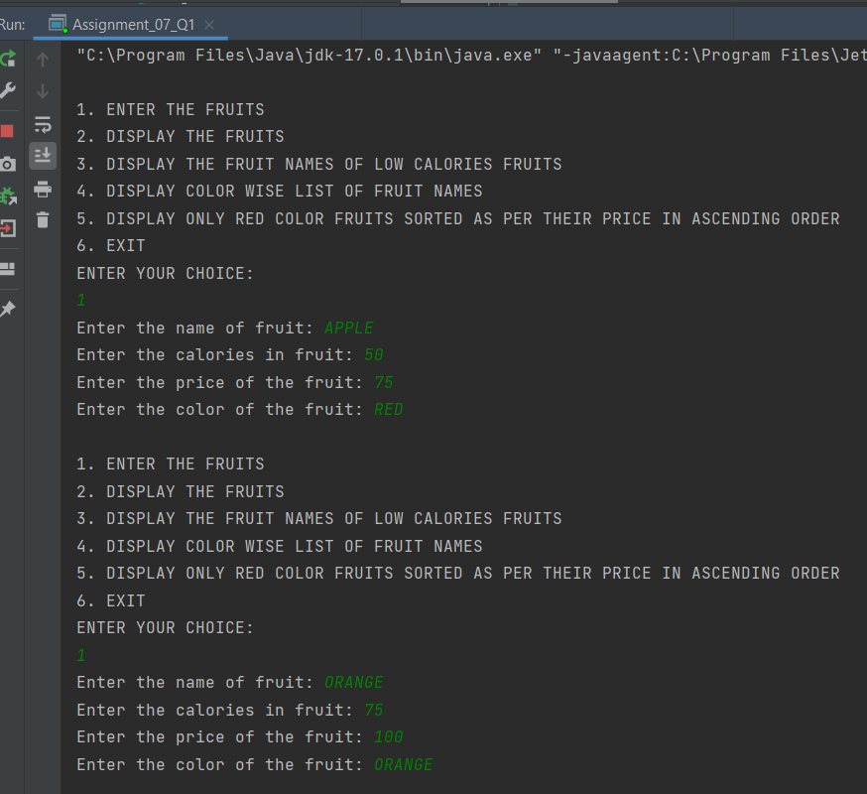

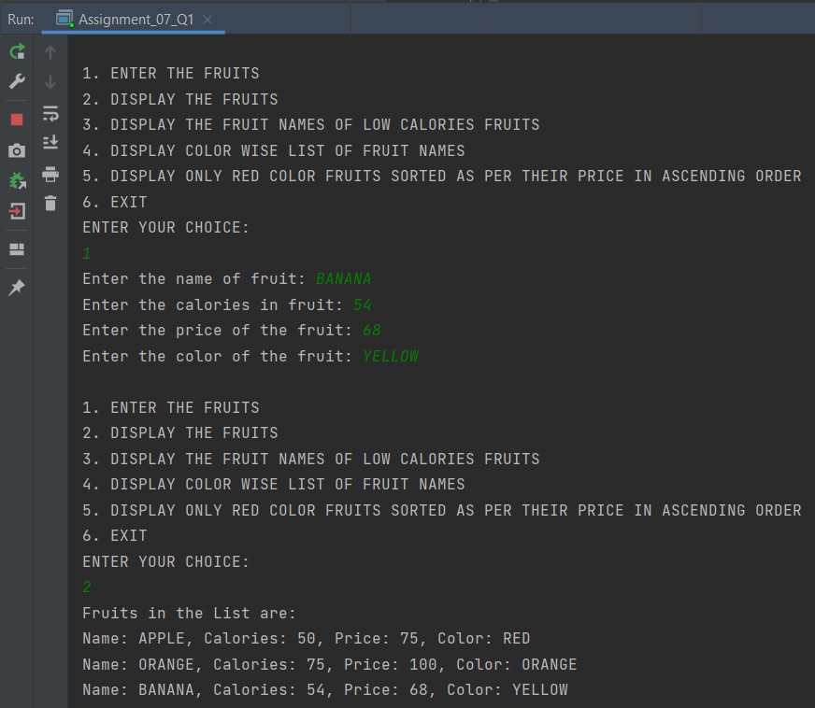

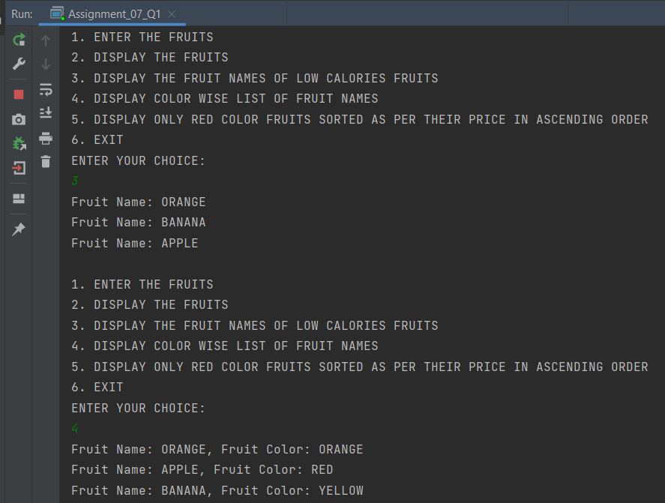

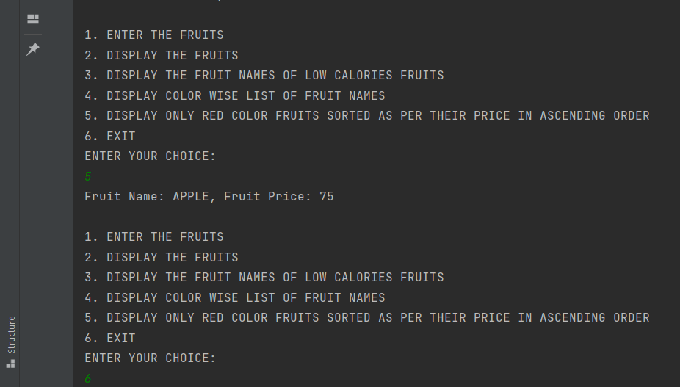

**Q2**

Setup:

Create the following classes:

class News { int newsId; String postedByUser; String commentByUser; String comment; }

**Find Out:**

**1. Find out the newsId which has received maximum comments.**

**2. Find out how many times the word 'budget' arrived in user comments all news.**

**3. Find out which user has posted maximum comments.**

**4. Display commentByUser wise number of comments.**

**Code Specifications:**

class News {  
    private int newsId;  
    private String postedByUser;  
    private String commentByUser;  
    private String comment;  
}  
  
public class Assignment5Q2 {  
    public static int maxComments(List<News> news) {}

    public static int budgetCount (List < News > news) {}  
    public static String maxCommentsByUser (List < News > news) {}

    public static Map<String, Integer> sortMaxCommentsByUser (List < News > news) {}

    public static void main(String[] args) {}  
}

package com.company;  
import java.util.*;  
import java.util.stream.Collectors;  
class News {  
 int newsId;  
 String postedByUser;  
 String commentByUser;  
 String comment;  
  
 public News(int newsId, String postedByUser, String commentByUser, String comment) {  
 this.newsId = newsId;  
 this.postedByUser = postedByUser;  
 this.commentByUser = commentByUser;  
 this.comment = comment;  
 }  
  
 public News() {  
 }  
  
 public int getNewsId() {  
 return newsId;  
 }  
  
 public void setNewsId(int newsId) {  
 this.newsId = newsId;  
 }  
  
 public String getPostedByUser() {  
 return postedByUser;  
 }  
  
 public void setPostedByUser(String postedByUser) {  
 this.postedByUser= postedByUser;  
 }  
  
 public String getCommentByUser() {  
 return commentByUser;  
 }  
  
 public void setCommentByUser(String commentByUser) {  
 this.commentByUser= commentByUser;  
 }  
  
 public String getComment() {  
 return comment;  
 }  
  
 public void setComment(String comment) {  
 this.comment= comment;  
 }  
  
 @Override  
 public boolean equals(Object o) {  
 if (this == o) return true;  
 if (!(o instanceof News)) return false;  
 News news= (News) o;  
 return newsId== news.newsId&&commentByUser.equals(news.commentByUser) &&comment.equals(news.comment);  
 }  
  
 @Override  
 public int hashCode() {  
 return Objects.*hash*(newsId, commentByUser, comment);  
 }  
  
}  
  
public class Assignment_07_Q2 {  
 public static int maxComments(List<News>news) {  
  
 Map<Integer,Integer>map = new HashMap<>();  
  
 for (News news1: news){  
 int id = news1.getNewsId();  
 if(map.containsKey(id)){  
 map.put(id,map.get(id)+1);  
 } else {  
 map.put(id,1);  
 }  
 }  
 List<Map.Entry<Integer, Integer>>list = new ArrayList<>(map.entrySet());  
 list.sort(Map.Entry.*comparingByValue*());  
 return list.get(list.size()-1).getKey();  
 }  
  
 public static int budgetCount(List <News >news) {  
 int count = 0;  
 List<String>list = new ArrayList<>();  
 for(News i: news){  
 String comment = i.getComment();  
 list.add(Arrays.*toString*(comment.split("budget")));  
 }  
  
 return list.size();  
 }  
  
 public static String maxCommentsByUser(List <News >news) {  
 Map<String,Integer>map = new HashMap<>();  
  
 for(News news1: news){  
 String username = news1.getCommentByUser();  
 if(map.containsKey(username)){  
 map.put(username,map.get(username)+1);  
 } else {  
 map.put(username,1);  
 }  
 }  
 List<Map.Entry<String, Integer>>list = new ArrayList<>(map.entrySet());  
 list.sort(Map.Entry.*comparingByValue*());  
 return list.get(list.size()-1).getKey();  
 }  
 public static Map<String, Integer>sortMaxCommentsByUser(List <News >news) {  
 Map<String,Integer>map = new HashMap<>();  
 for(News news1: news){  
 String username = news1.getCommentByUser();  
 if(map.containsKey(username)){  
 map.put(username,map.get(username)+1);  
 } else {  
 map.put(username,1);  
 }  
 }  
 HashMap<String, Integer>temp  
 = map.entrySet()  
 .stream()  
 .sorted((i1, i2)  
 ->i2.getValue().compareTo(  
 i1.getValue()))  
 .collect(Collectors.*toMap*(  
 Map.Entry::getKey,  
 Map.Entry::getValue,  
 (e1, e2) ->e1, LinkedHashMap::new));  
 return temp;  
 }  
  
 public static void main(String[] args) throws Exception {  
  
 List<News>list = new ArrayList<>();  
 int choice;  
 Scanner sc= new Scanner(System.*in*);  
  
 News news1 = new News(1,  
 "POST1",  
 "COMMENT1",  
 "I want to see the budget");  
  
 News news2 = new News(1,  
 "POST2",  
 "COMMENT2",  
 "budget is my fundamental right");  
  
 News news3 = new News(2,  
 "POST3",  
 "COMMENT2",  
 "budget 2022");  
  
  
 list.add(news1);  
 list.add(news2);  
 list.add(news3);  
  
  
  
 do{  
 System.*out*.println("1. ENTER THE NEWS DETAILS");  
 System.*out*.println("2. DISPLAY THE NEWS DETAILS");  
 System.*out*.println("3. FIND OUT THE newsId WHICH HAS RECEIVED MAXIMUM COMMENTS.");  
 System.*out*.println("4. FIND OUT HOW MANY TIMES THE WORD 'BUDGET' ARRIVED IN USER COMMENTS ALL NEWS.");  
 System.*out*.println("5. FIND OUT WHICH USER HAS POSTED MAXIMUM COMMENTS.");  
 System.*out*.println("6. DISPLAY COMMENT BY USER WISE NUMBER OF COMMENTS.");  
 System.*out*.println("7. EXIT");  
 System.*out*.println("ENTER YOUR CHOICE:");  
 choice = sc.nextInt();  
  
 switch (choice){  
 case 1:  
 News news= new News();  
  
 {  
 System.*out*.print("Enter the newsID: ");  
 int newId= sc.nextInt();  
 news.setNewsId(newId);  
  
 sc.nextLine();  
 System.*out*.print("Enter the name who posted the news: ");  
 String name = sc.nextLine();  
 news.setPostedByUser(name);  
  
  
 System.*out*.print("Enter the comment: ");  
 String comment = sc.nextLine();  
 news.setComment(comment);  
  
 System.*out*.print("Enter the name who posted the comment: ");  
 String username = sc.nextLine();  
 news.setCommentByUser(username);  
  
 list.add(news);  
  
 }  
 break;  
  
 case 2: for(News new1: list){  
 System.*out*.println("News ID: "+new1.getNewsId());  
 System.*out*.println("News Posted By: "+new1.getPostedByUser());  
 System.*out*.println("Comment by User: "+new1.getCommentByUser());  
 System.*out*.println("Comment Posted: "+new1.getComment());  
 System.*out*.println();  
 }  
 break;  
  
 case 3: int id = *maxComments*(list);  
 System.*out*.println("NEWS ID WHICH HAS RECEIVED MAXIMUM COMMENTS: "+id);  
 System.*out*.println();  
 break;  
  
 case 4: int countBudget= *budgetCount*(list);  
 System.*out*.println("HOW MANY TIMES THE WORD 'BUDGET' ARRIVED IN USER COMMENTS ALL NEWS: "+countBudget);  
 System.*out*.println();  
 break;  
  
 case 5: String name = *maxCommentsByUser*(list);  
 System.*out*.println("USER HAS POSTED MAXIMUM COMMENTS: "+name);  
 System.*out*.println();  
 break;  
  
 case 6: Map<String,Integer>maxCommentByUser= *sortMaxCommentsByUser*(list);  
  
 for (Map.Entry<String,Integer>mp: maxCommentByUser.entrySet()){  
 System.*out*.println("Name of the User: "+mp.getKey());  
 System.*out*.println("Numbers of Comments: "+mp.getValue());  
 System.*out*.println();  
 }  
 System.*out*.println();  
 break;  
 }  
 }while (choice!=7);  
 }  
}

OUTPUT :-

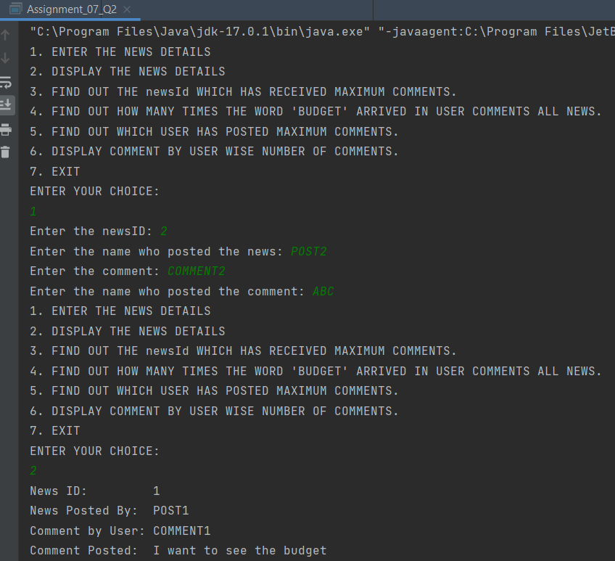

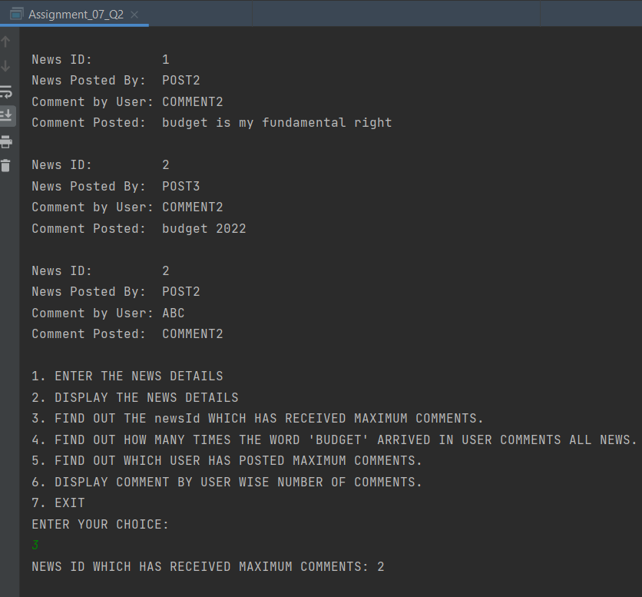

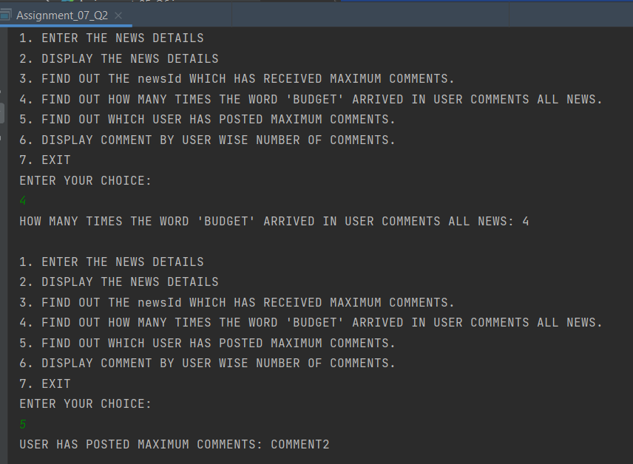

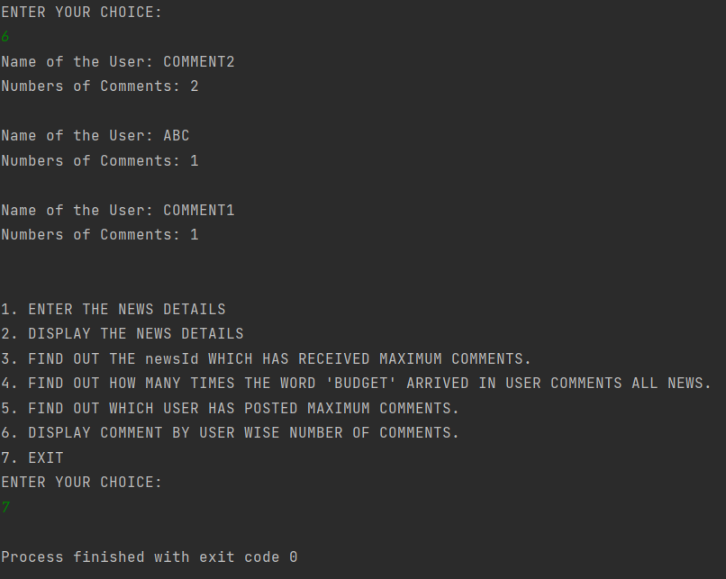

**Q3**

Create the following classes:

class Trader { String name; String city; }

**Find Out:**

**1. What are all the unique cities where the traders work?**

**2. Find all traders from Pune and sort them by name.**

**3. Return a string of all traders’ names sorted alphabetically.**

**4. Are any traders based in Indore?**

**Code Specifications:**

class Trader {  
    private String name;  
    private String city;  
}  
  
public class Assignment5Q9 {  
    public static List<String> printUniqueCities (List <Trader> traders) {  }

    public static List<String> tradersFromPuneSortByName(List<Trader> traders) {}  
    public static String allTrader3Names(List<Trader> traders) {}  
    public static ArrayList<Trader> areAnyTradersFromIndore(ArrayList<Trader> traders) {}

    public static void main(String[] args) {}  
}

package com.company;  
import java.util.*;  
  
class Trader {  
 String name;  
 String city;  
  
 public Trader(String name, String city) {  
 this.name = name;  
 this.city = city;  
 }  
 public Trader(){  
  
 }  
  
 public String getName() {  
 return name;  
 }  
  
 public void setName(String name) {  
 this.name = name;  
 }  
  
 public String getCity() {  
 return city;  
 }  
  
 public void setCity(String city) {  
 this.city = city;  
 }  
  
 @Override  
 public boolean equals(Object o) {  
 if (this == o) return true;  
 if (!(o instanceof Trader)) return false;  
 Trader trader= (Trader) o;  
 return name.equals(trader.name) &&city.equals(trader.city);  
 }  
  
 @Override  
 public int hashCode() {  
 return Objects.*hash*(name, city);  
 }  
  
 public static Comparator<Trader>*comparator* = new Comparator<Trader>() {  
 @Override  
 public int compare(Trader o1, Trader o2) {  
 return o1.getName().compareTo(o2.getName());  
 }  
 };  
}  
  
  
public class Assignment_07_Q3 {  
  
 public static List<String>printUniqueCities(List <Trader>traders) {  
  
 Map<String,String>map = new HashMap<>();  
 List<String>cities = new ArrayList<>();  
  
 for (Trader trader: traders){  
 map.putIfAbsent(trader.getCity(),trader.getName());  
 }  
  
 for (Map.Entry<String,String>mp: map.entrySet()){  
 cities.add(mp.getKey());  
 }  
 return cities;  
 }  
  
 public static List<String>tradersFromPuneSortByName(List<Trader>traders) {  
 List<String>tradersFromPune= new ArrayList<>();  
  
 for (Trader trader: traders){  
 if(trader.getCity().toUpperCase().equals("PUNE")){  
 tradersFromPune.add(trader.getName());  
 }  
 }  
  
 Collections.*sort*(tradersFromPune);  
 return tradersFromPune;  
 }  
 public static List<Trader>allTrader3Names(List<Trader>traders) {  
 traders.sort(Trader.*comparator*);  
 return traders;  
 }  
 public static ArrayList<Trader>areAnyTradersFromIndore(ArrayList<Trader>traders) {  
 ArrayList<Trader>traderList= new ArrayList<>();  
  
 for(Trader trader: traders){  
 if(trader.getCity().toUpperCase().equals("INDORE")){  
 traderList.add(trader);  
 }  
 }  
 return traderList;  
 }  
  
 public static void main(String[] args) {  
 Scanner sc= new Scanner(System.*in*);  
  
 ArrayList<Trader>arrayList= new ArrayList<>();  
  
 Trader trader1 = new Trader("ABC","Bhopal");  
 Trader trader2 = new Trader("DEF","Gwalior");  
 Trader trader3 = new Trader("GHI","Pune");  
 Trader trader4 = new Trader("JKL","Mumbai");  
 Trader trader5 = new Trader("MNO","Indore");  
 Trader trader6 = new Trader("PQR","Indore");  
  
 arrayList.add(trader1);  
 arrayList.add(trader2);  
 arrayList.add(trader3);  
 arrayList.add(trader4);  
 arrayList.add(trader5);  
 arrayList.add(trader6);  
  
 int choice;  
 do{  
 System.*out*.println("\n1. ENTER THE TRADERS DETAILS");  
 System.*out*.println("2. DISPLAY THE TRADERS DETAILS");  
 System.*out*.println("3. DISPLAY ALL UNIQUE CITIES WHERE TRADERS WORK");  
 System.*out*.println("4. DISPLAY ALL TRADERS FROM PUNE SORTED BY NAME");  
 System.*out*.println("5. DISPLAY ALL TRADERS NAMES SORTED ALPHABETICALLY");  
 System.*out*.println("6. DISPLAY ALL TRADERS FROM INDORE");  
 System.*out*.println("7. EXIT");  
 System.*out*.println("ENTER YOUR CHOICE");  
 choice = sc.nextInt();  
  
 switch (choice){  
 case 1:  
 Trader trader= new Trader();  
 sc.nextLine();  
 System.*out*.println("Enter the Trader Name: ");  
 String name = sc.nextLine();  
 trader.setName(name);  
  
 System.*out*.println("Enter the City Name: ");  
 String city = sc.nextLine();  
 trader.setCity(city);  
  
 arrayList.add(trader);  
 break;  
  
 case 2:  
 System.*out*.println("List of traders: ");  
 for (Trader trade: arrayList){  
 System.*out*.println("Trader Name: "+trade.getName());  
 System.*out*.println("Trader City: "+trade.getCity());  
 }  
 System.*out*.println();  
 break;  
  
 case 3:  
 List<String>list = new ArrayList<>();  
 list = *printUniqueCities*(arrayList);  
  
 System.*out*.println("All uniques cities where traders work: ");  
 for (String str: list){  
 System.*out*.println(str);  
 }  
 System.*out*.println();  
 break;  
  
 case 4:  
 List<String>list1 = new ArrayList<>();  
 list1 = *tradersFromPuneSortByName*(arrayList);  
  
 System.*out*.println("All traders from Pune: ");  
 for (String str: list1){  
 System.*out*.println(str);  
 }  
 System.*out*.println();  
 break;  
  
 case 5: List<Trader>arraylist2 = new ArrayList<>();  
 arraylist2 = *allTrader3Names*(arrayList);  
  
 System.*out*.println("All Traders Name:");  
 for(Trader trader7: arraylist2){  
 System.*out*.println("Name: "+trader7.getName());  
 System.*out*.println("City: "+trader7.getCity());  
 System.*out*.println();  
 }  
 System.*out*.println();  
 break;  
  
 case 6: List<Trader>traderList= new ArrayList<>();  
 traderList= *areAnyTradersFromIndore*(arrayList);  
 System.*out*.println("All traders from Indore: ");  
 for(Trader trader7: traderList){  
 System.*out*.println("Name: "+trader7.getName());  
 }  
 System.*out*.println();  
 break;  
  
  
 case 7: System.*exit*(0);  
  
 default:  
 System.*out*.println("PLEASE ENTER THE RIGHT CHOICE!");  
 }  
 } while (choice!=7);  
 }  
}

OUTPUT :-

